4th EUROPEAN COLORECTAL CANCER DAYS

29–30 May 2015, Brno (Czech Republic) – www.crcprevention.eu: conference focused on issues related to colorectal cancer prevention and treatment in the EU and in the Czech Republic
The conference is organised and the report has been prepared by: Pavel Poc, Member of the European Parliament; Institute of Biostatistics and Analyses, Masaryk University, Brno (www.iba.muni.cz); Institute of Health Information and Statistics of the Czech Republic (www.uzis.cz).

Summary information on colorectal cancer (CRC) in the Czech Republic
- High number of patients. The Czech Republic still has one of the highest rates of colorectal cancer worldwide. Each year almost 8,000 patients are diagnosed with colorectal cancer in this country, and there are about 4,000 CRC deaths. The good news is that the incidence rate (i.e., number of new CRC cases) has stabilised and that the mortality rate (i.e., number of CRC deaths) has decreased. These trends, however, have led to an increase in the numbers of treated and cured patients, who require further care. Nowadays, there are more than 60,000 citizens living in the Czech Republic who have had colorectal cancer in their medical history.
- Cancers diagnosed too late. The situation is aggravated by the fact that more than 50% of patients are still diagnosed at advanced stages of the disease, which implies lower chances of a complete cure. Such patients also require a comprehensive care, including the specialised care in Comprehensive Cancer Centres all across the Czech Republic.
- Existence of a screening programme (www.kolorektum.cz). Every Czech citizen aged above 50 is eligible for an examination by faecal occult blood test (FOBT), and those aged above 55 can also undergo primary screening colonoscopy. Citizens enter the screening programme by visiting their GPs (or gynaecologists, for women). The screening programme is reimbursed from the public health insurance funds, i.e. the citizens do not pay any additional fees.
- New project of personalised invitations of citizens to screening aiming to increase the participation rate. Although the participation rate in the Czech screening programme has slightly increased, it is still too low (27% in 2013). A project of personalised invitations of Czech citizens to cancer screening programmes, supported by the EU funds, was launched in 2014. Invitations are sent to citizens who have not participated in screening yet. An appeal needs to be made particularly to these citizens, reminding them to consider the invitation as an opportunity to prevent the disease.
- Challenge for the Czech Republic: availability of care. Management of CRC patients has been far from optimal in the Czech Republic: large differences among regions have been observed, including differences in the availability of care. There are alarming differences in the screening coverage: individual regions differ by up to 20%. Relatively poor centralisation of surgical treatment has been well documented, involving a limited availability of timely surgery for liver metastases from colorectal cancer, for example. Similarly, less than a half of patients have access to indicated targeted therapies in Comprehensive Cancer Centres. An inadequate access of Czech patients to innovative therapies was pointed out in the OECD Cancer Care report from 2013.
- Challenge for the Czech Republic: strengthening prevention strategies in general. The Czech Republic has much space for improvement in measures aimed at strengthening cancer prevention in general. According to an OECD survey (Health at a Glance, Europe 2014), the Czech population has much higher alcohol consumption, obesity rates, and a very high consumption of tobacco products when compared to other developed countries. Measures adopted by the Czech authorities, for example anti-smoking measures, have been still inadequate.
- Good news: longer survival of cancer patients. In terms of cancer care results, data from national and international studies have shown that the Czech Republic has been closing the gap on the European average, and is standing out above the average of East European countries. The same applies for colorectal cancer, too.

Colorectal cancer – one of the most common cancers worldwide and in Europe
Colorectal cancer (CRC) is one of the most common cancers worldwide, and is among the leading causes of cancer deaths in developed countries. It is the third most common cancer worldwide (excluding non-melanoma skin cancer), and actually the most common cancer in Europe (excluding non-melanoma skin cancer). According to estimates by the GLOBOCAN study, more than 1.3 million new cases of CRC were diagnosed worldwide in 2012, and almost 700,000 people died of the disease. In the same year, almost 450,000 CRC patients were diagnosed in Europe, and there were almost 215,000 CRC deaths. Table 1 shows data about CRC incidence and mortality in more detail.
Table 1: CRC epidemiology worldwide and in Europe. Source of data: Ferlay et al., 2013
 |  | Men | Women | Both
World | Incidence – number of new cases | 746,298 | 614,304 | 1,360,602
 | Incidence – Czech Republic ranking | 4th | 16th | 6th
 | Mortality – number of deaths | 373,639 | 320,294 | 693,933
 | Mortality – Czech Republic ranking | 6th | 31st | 11th
Europe | Incidence – number of new cases | 241,813 | 205,323 | 447,136
 | Incidence – Czech Republic ranking | 3rd | 10th | 5th
 | Mortality – number of deaths | 113,246 | 101,620 | 214,866
 | Mortality – Czech Republic ranking | 6th | 20th | 9th

The Czech Republic is characterised by a high burden of colorectal cancer, ranking on the top positions when compared to other countries. Czech male colorectal cancer incidence rates (i.e., numbers of newly diagnosed cases of CRC) rank 4th worldwide and 3rd in Europe, while female rates rank 16th worldwide and 10th in Europe. When taking both sexes into account, the Czech CRC incidence rates rank 6th worldwide and 5th in Europe (Table 1, Figure 1). International statistics have shown that CRC is a disease typically occurring in Central and West European countries, and have confirmed that CRC is more common in men than in women.

Thousands of people die of colorectal cancer in the Czech Republic each year
Each year, almost 8,000 citizens of the Czech Republic receive the diagnosis of colorectal cancer, and almost 4,000 people die from the disease (Table 2). Colorectal cancer therefore significantly contributes to the overall cancer burden of the Czech population: it is the second most common cancer in both sexes (after prostate cancer in men, and breast cancer in women). Additionally, although CRC is more common in elderly people (a typical Czech CRC patient is aged between 61 and 77 years), it affects many people of working age: about a fifth of patients are diagnosed at the age of under 60.

Figure 1: Colorectal cancer incidence rates worldwide and in Europe. Source of data: Ferlay et al., 2013
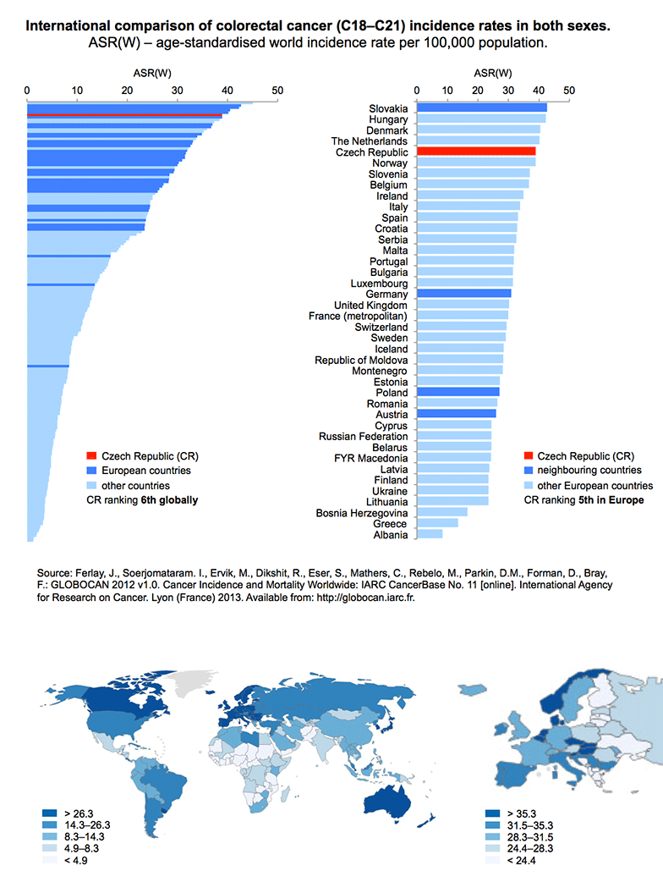
Table 2: CRC epidemiology in the Czech Republic.
 | Year 2012¹ | Year 2015²
Number of new CRC cases in the Czech Republic per year (incidence)  (absolute numbers / rate per 100,000 population) | 7,940 / 75.55 | 8,578
Number of CRC deaths in the Czech Republic per year (mortality)  (absolute numbers / rate per 100,000 population) | 3,938 / 37.47 | ---
Number of living persons with CRC in their medical history (prevalence) | 53,701 | 65,810
¹ Source of data: Czech National Cancer Registry, www.svod.cz
² Source of data: Predicted numbers of cancer patients by the Czech Society for Oncology
The Czech National Cancer Registry makes it possible to analyse long-term trends in cancer incidence and mortality rates (Figure 2). A stabilisation of CRC incidence rates and a slight decrease in CRC mortality rates have been observed over the last few years. Although this trend can be considered as positive, the widening gap between incidence and mortality curves has inevitably led to a considerable increase in prevalence, i.e. the number of patients alive who have had colorectal cancer in their medical history. In 2012 in the Czech Republic, there were almost 54,000 patients with CRC in their medical history, and a significant rise of this number is expected in the years to come (Table 2). The overall epidemiological burden of the Czech population is further aggravated by the occurrence of colorectal cancer as a subsequent (second, or even third) primary cancer in the same patient; in other words, colorectal cancers are diagnosed in patients who were treated for another type of cancer in the past. Both of the above-mentioned facts – the increasing CRC prevalence, and the occurrence of subsequent primary cancers – mean that there is an ever increasing pressure on cancer care facilities, which of course must provide care to these patients as well, and on the entire health care system, which pays for their treatment.

Figure 2: Long-term time trends in incidence and mortality rates for colorectal cancer in the Czech Republic. Source of data: Czech National Cancer Registry, www.svod.cz
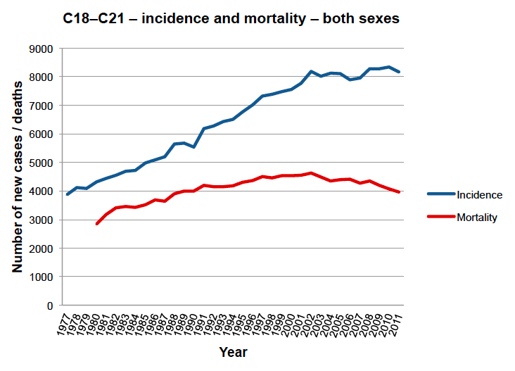

Late diagnosis = lower chance of cure
It is widely known that a cancer diagnosed at an early stage (or even at the stage of precancerous changes) is much more likely to be treated successfully, and that the chance of survival in such cases is much higher. Available population-based data on colorectal cancer epidemiology in the Czech Republic, however, describes a rather gloomy situation. Figure 3 shows that more than 50% of new colorectal cancer patients in the Czech Republic are diagnosed with tumours in clinical stages III or IV. Moreover, the situation has not much improved over time: the latest available data from 2012 has not shown any positive trend. This inevitably leads to markedly poorer treatment results, let alone related costs, which are very high in patients with advanced cancers.
Despite the above-mentioned facts, recent studies have suggested that cancer treatment in the Czech Republic is nowadays much more successful than before. The 5-year relative survival (i.e., the percentage of patients with a disease that are alive five years after their disease is diagnosed, related to the general population without that disease) is a standard benchmark of treatment success. Analysis of data from the Czech National Cancer Registry, performed by the Institute of Biostatistics and Analyses of the Masaryk University, has confirmed that survival rates of Czech CRC patients have improved; on the other hand, there are still huge differences in the chances of survival between patients who were diagnosed at an early stages of the disease and those who were diagnosed at advanced stages (Table 3). These numbers clearly demonstrate how important it is to detect cancers at early stages, when there is a real chance of cure.

Figure 3: Proportion of clinical stages of CRC at the time of diagnosis. Source of data: Czech National Cancer Registry, www.svod.cz
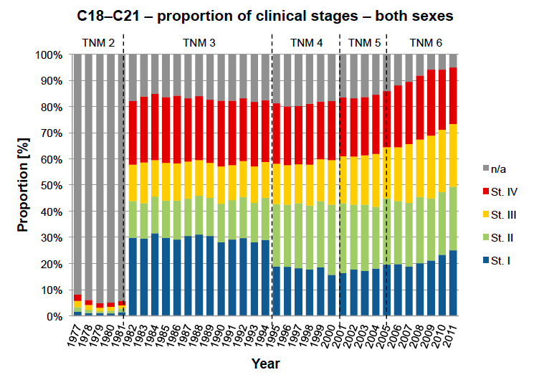
Table 3: Five-year relative survival of treated CRC patients according to data from the Czech National Cancer Registry in the periods 2000–2003, 2004–2007, and 2008–2011. Source of data: Czech National Cancer Registry, Institute of Biostatistics and Analyses of the Masaryk University (IBA MU)
 | 5-year relative survival in the period 2000–2003 (%) | 5-year relative survival in the period 2004–2007 (%) | 5-year relative survival in the period 2008–2011 (%)
Clinical stage I | 80.2 | 85.4 | 90.0
Clinical stage II | 65.8 | 71.6 | 77.1
Clinical stage III | 45.7 | 52.0 | 58.0
Clinical stage IV | 11.2 | 12.9 | 14.5
All stages | 53.0 | 57.3 | 62.0

The European study EUROCARE-5 analysed data from cancer registries of 29 countries in order to compare 5-year survival rates of more than 9 million cancer patients in the period 2000–2007. The study confirmed that results of the Czech cancer care have been catching up with the European average, and that in a large majority of cancers, including colorectal cancer, survival rates of Czech cancer patients are much better than those in other countries of the former Eastern Bloc (Table 4).

Table 4: Five-year relative survival of CRC patients according to the EUROCARE-5 study in the period 2000–2007 (De Angelis et al., 2014).
 | Colon cancer (%) | Rectal cancer (%)
Northern Europe | 59.0 | 59.5
UK and Ireland | 51.8 | 53.7
Central Europe | 60.5 | 60.1
Southern Europe | 58.5 | 55.4
Eastern Europe | 49.4 | 44.6
Czech Republic | 52.5 | 48.7
European average | 57.0 | 55.8

An opportunity for change: invitations of citizens to screening programme
The term “screening” refers to regular preventive checkups of persons from the defined target group that do not show any symptoms of a given disease. If someone reports blood in the stools, frequent constipation, diarrhoea, or other symptoms possibly linked to CRC, then the examination of such person is not referred to as screening, but as a diagnostic examination, potentially revealing a disease of the gastrointestinal tract. Similarly, if bowel cancer or another bowel condition has occurred relatively frequently in the family history of a given patient, then this patient is considered to be at a higher risk of CRC, and should undergo preventive checkups even more frequently than the standard recommended interval between screening examination.
The colorectal cancer screening programme in the Czech Republic is available for all citizens of the Czech Republic aged above 50, and involves two types of examination:
- Faecal occult blood test (available at GPs’ and gynaecologists’ practices)
- Screening colonoscopy (performed by specialised gastroenterology facilities, their list is available at www.kolorektum.cz, for example; a client is referred to this examination by his/her GP or gynaecologist)
The screening programme is divided into two categories, according to age groups of the target population (Figure 4). A client aged 50–54 is entitled to have a free-of-charge faecal occult blood test (FOBT) each year, provided by his/her registering GP or gynaecologist. In case of a negative result (no blood in the stools), FOBT is performed again after one year. In case of a positive result (blood in the stools detected), the client is referred to a facility performing screening colonoscopy. If no cancer is detected by colonoscopy, the screening programme will be suspended for 10 years for this client. A client aged over 55 can choose between FOBT (once per two years) and primary screening colonoscopy. The subsequent process is similar to that in the younger age group: colonoscopy follows after a positive result of FOBT, and another colonoscopic examination is performed 10 years after a negative result of colonoscopy.
The Czech screening programme is organised, which means that there is a system guaranteeing its effectiveness and safety. The Czech Ministry of Health and its Colorectal Cancer Screening Committee are the main guarantors of the programme. The Committee involves representatives of the participating medical specialties (gastroenterologists, GPs, gynaecologists, oncologists), the Czech Ministry of Health, and health insurance companies. The programme effectiveness and safety is monitored using data provided by the Czech National Reference Centre (data from health insurance companies) and by individual facilities performing screening colonoscopies. Evaluation of this data is performed by the Institute of Biostatistics and Analyses of the Masaryk University, which also provides comprehensive background information for the programme.
Partly due to discussions and conclusions of the first two years of the European Colorectal Cancer Days, a project of personalised invitations of citizens to cancer screening programme has been under way since the 1 January 2014. This step converted the Czech screening programme into a population-based one, ensuring the highest level of organisation according to criteria defined by the International Agency for Research on Cancer (IARC). Each insured person aged over 50, who has not participated in preventive checkup over the last few years, will obtain an invitation with detailed instructions on what he/she should do, and what examinations are performed as part of the screening programme. The objective of personalised invitations is to increase the insufficient participation rates in cancer screening programmes, particularly in colorectal cancer screening, where the participation rate only reached 26% before the introduction of personalised invitations. In order to achieve a drop in mortality rates from colorectal cancer on the population level, this proportion should be at least doubled. The project is accompanied by an education campaign, explaining the importance and benefits of preventive examinations to target groups of the population. Non-profit organisations and patient organisations (Onkomajak, League Against Cancer, Czech ILCO and others) also make efforts to promote the screening programme and to inform the public.
Figure 4: Schematic representation of CRC screening process in the Czech Republic for clients aged 50–54 years (on the left), and those aged 55 and above (on the right). Source: www.kolorektum.cz
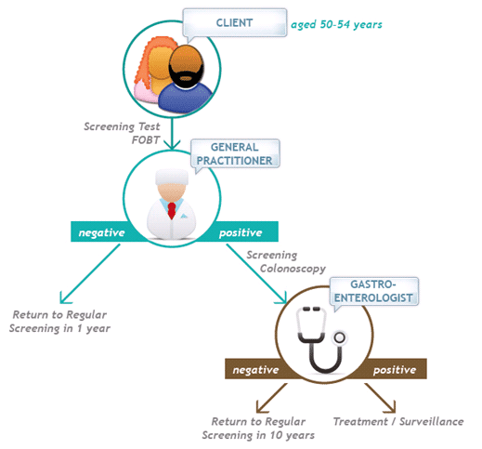 | 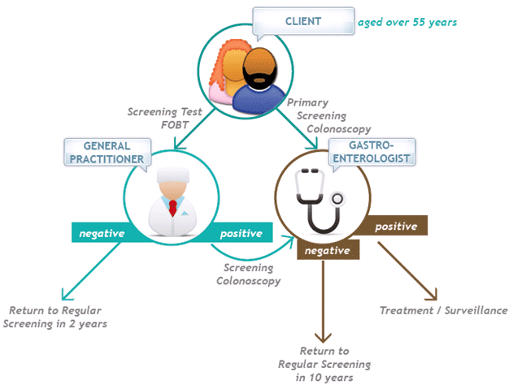

Care for patients must be early, comprehensive, multidisciplinary

… and available, above all
Physicians of various specialties contribute to colorectal cancer diagnosis and treatment: GPs, gynaecologists and gastroenterologists are involved in CRC diagnosis, while oncologists, surgeons and radiotherapists participate in CRC treatment. The maximum benefit for the patient can be only achieved if these specialists cooperate effectively. Treatment of cancers, particularly the advanced ones, is concentrated to 13 Comprehensive Cancer Centres all across the Czech Republic; other health care facilities in the individual regions should cooperate with them closely. Despite the existence of cancer centres, there is much space for improvement in cancer care. Late diagnosis of CRC is not only the result of a low awareness of the general public, but also a consequence of insufficient activity of the primary care network: there are still huge differences among individual regions in the coverage of the target population by screening. The same phenomenon has been documented in the availability of care: a large proportion of patients at advanced stages of the disease have no access to specialised treatment in the network of Comprehensive Cancer Centres, whether it be surgical treatment or therapy by innovative drugs. Available data also point out a massive migration of patients among individual health care facilities, even in the course of treatment. Reimbursements for care, however, do not migrate with the patients; this complicates the situation for specialised centres, which are particularly burdened with patient migration. The motto “Right treatment for the right patient at the right time and in the right place” of the Czech National Cancer Control Programme, which was adopted by the Czech Society for Oncology in 2003 (and revised in 2013), has therefore not been satisfactorily fulfilled yet.

Primary prevention is key
Risk factors for cancer, including colorectal cancer, are generally known. Apart from factors that can only hardly be influenced by an individual (such as the genetic predisposition or environmental contamination), the risk factors involve smoking, excessive consumption of red meats, processed meats and alcohol, lack of physical exercise, and other typical features of the so-called “Western” lifestyle. This is one of the reasons why the highest CRC incidence rates have been repeatedly reported in Europe and North America. Comparison of individual countries based on the population health (and health care systems) is regularly performed by the Organisation for Economic Co-operation and Development (OECD) in the publication “Health at a Glance”. When compared to international statistics, the Czech Republic has rather gloomy outlooks: the consumption of alcohol per capita is one of the highest among the OECD countries, the prevalence of obesity has seen a significant rise, and smoking rates have actually increased in the past decades, in contrast to other European countries. The promotion of primary prevention by the lawmakers, authorities and the Ministry of Health itself is inadequate. According to OECD experts, “a comprehensive approach is needed to reduce risk factors for cancer and improve lifestyles, involving all stakeholders such as industry, the entire population (including children and their parents), and health care providers including primary care doctors”.
In the context of the above-mentioned facts, and taking into account ageing of the Czech population, a further rise in the prevalence of cancer patients can be expected, with inevitable social and financial consequences.

Information sources on colorectal cancer
- www.kolorektum.cz – Colorectal Cancer Screening Programme in the Czech Republic
- www.onconet.cz – Czech National Cancer Screening Programme
- www.linkos.cz – Czech Society for Oncology
- www.svod.cz – Cancer epidemiology in the Czech Republic on-line

Literature
De Angelis R, Sant M, Coleman MP, Francisci S, Baili P, Pierannunzio D, Trama A, Visser O, Brenner H, Ardanaz E, Bielska-Lasota M, Engholm G, Nennecke A, Siesling S, Berrino F, Capocaccia R; EUROCARE-5 Working Group. Cancer survival in Europe 1999-2007 by country and age: results of EUROCARE-5-a population-based study. Lancet Oncol 2014; 15(1): 23–34. DOI: 10.1016/S1470-2045(13)70546-1
Ferlay J, Soerjomataram I, Ervik M, Dikshit R, Eser S, Mathers C, Rebelo M, Parkin DM, Forman D, Bray, F.GLOBOCAN 2012 v1.0, Cancer Incidence and Mortality Worldwide: IARC CancerBase No. 11 [Internet]. Lyon, France: International Agency for Research on Cancer; 2013. Available from: http://globocan.iarc.fr. Accessed on 14/05/2015
OECD. Health at a Glance: Europe 2014. OECD Publishing 2014. http://dx.doi.org/10.1787/health_glance_eur-2014-en
OECD. Cancer Care: Assuring Quality to Improve Survival. Country note – Czech Republic. OECD Publishing, 2014. http://www.oecd.org/els/health-systems/Cancer-Care-Czech-Republic-2013.pdf
Pavlík T, Májek O, Büchler T, Vyzula R, Petera J, Ryska M, Ryška A, Cibula D, Babjuk M, Abrahámová J, Vorlíček J, Mužík J, Dušek L. Trends in stage-specific population-based survival of cancer patients in the Czech Republic in the period 2000-2008. Cancer Epidemiol 2014; 38(1): 28-34. DOI: 10.1016/j.canep.2013.11.002

